Milton Primary School
Information Handbook
2020 - 2021
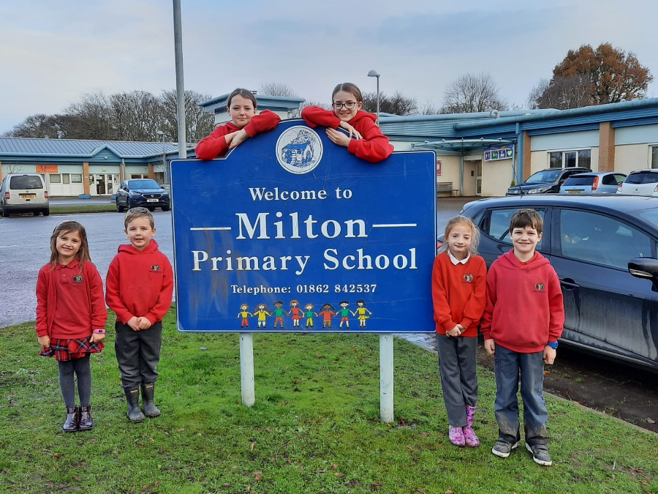

Milton Primary School
Invergordon
IV18 0PX

Head Teacher: Gemma Dunnett
Tel. 01862 842 537
e-mail: milton.primary@highland.gov.uk

School Website: www.miltonprimary.com

Stages Taught: P1 - P7
Current Roll: 61
1. CONTENTS PAGE
- Contents Page
- Welcome from the Head Teacher
- Vision & Aims
- Milton Primary School Staff

General School Information:
- Parent Council
- Parental Involvement
- Pupil’s Absence
- Complaints Procedure
- Transport
- Placement Requests
- School Ethos & The Curriculum at Milton
- Promoting Positive Behaviour
- Assessment & Reporting
- Enrolment
- Transition
- Support for Pupils
- School Improvement

School Policies and Practical Information:
- Term Dates & School Hours
- Homework
- Uniform
- Lost Property
- Lunchtime Choices
- Health Promoting School
- Extra-Curricular Activities
- Administration of Medicines
- Minor injuries
- Adverse Weather / Closure
- Fire Precaution
- Access to Pupil Records
- Data Protection Act 1998
- Transferring Educational data about pupils
- Data Policy
- Equality and Inclusion
- Protection of Children

The current pandemic has affected the normal running of schools in many ways. This Handbook reflects the way the school usually runs but does not cover all of the changes that we have made because of the pandemic. Our arrangements have changed in many ways this session, and may well change again, depending on how the pandemic develops. For the most up-to-date information about any aspect of the work of the school, please make contact and we will be able to tell you about our current arrangements. For the latest information about how the pandemic affects children, young people and families across Scotland, please visit the Scottish Government website, which has helpful information about Coronavirus and its impact on education and children.
2. Dear Parent,
I would like to offer you a warm welcome to Milton Primary School. I hope that you find our handbook both interesting and informative. The purpose of this handbook is to:
- communicate the ethos of our school and provide a welcome for parents to the school
- help parents to choose a school
- help you and your child prepare for school
- act as a reference tool while your child is at the school and provide you with what you need to know before you join us

Our total school roll at present is 61 (15 of those attend our Nursery) which is split into 3 composite classes, P1-3, P3-5 and P5-7. The teaching team at Milton feel that the bright, warm, happy ethos which exists provides an excellent learning environment for all children.
We strongly believe that children should experience success every single day; they should come to school ready to learn and leave with a sense of satisfaction. We feel that every achievement should be acknowledged and every underachievement should be challenged. Building motivation, resilience and confidence is important to us.
We look forward to getting to know you and your child and we believe that through building a positive partnership that together we can enable your child to be the best that they can be.

If you require any further information or details, please do not hesitate to contact me through the school office.

Yours sincerely,

Gemma Dunnett, Head Teacher

3. Vision: Staff, Parents and the Wider School Community work together to ensure that we #Dream #Believe #Achieve.

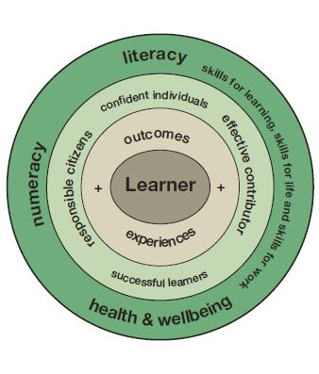
Staff
Parents

Wider school community

School Aims: At Milton Primary School our aim is for all children to feel Safe, Healthy, Active, Nurtured, Achieving, Respected, Responsible and Included.
Our children would like to explain the school aims to you…

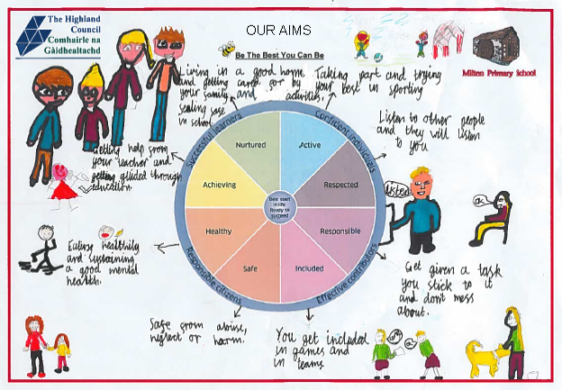

4. Milton Primary School Staff (Nov 2020)

Head Teacher Mrs Gemma Dunnett

Principal Teacher Mrs J. Christie

Class Teacher Miss A. Crew
Class Teacher Miss C. Robinson
Class Teacher Miss H Hunter (Job share with Mrs Christie)

Pupil Support Assistant Mrs L. Sutherland
Pupil Support Assistant Mrs R. MacDonald
Pupil Support Assistant Ms L. Nimmons
Pupil Support Assistant Miss S. Ross
Pupil Support Assistant Mrs L. Thain
Support and Inclusion Workers Miss S. Ross

Nursery Team
Early Years Practitioner Mrs E. Forth
Early Years Practitioner Mrs J. Sutherland
Early Years Support Worker Mrs K. Campbell

Support for Learning Teacher Mrs J. Sellar
Additional Teaching Staff Mrs A. Martin

Clerical Ms L. Nimmons
Cook Ms M. Sutherland
Cook Assistant Ms C. Murdoch
Cleaners Mrs N. Anderson & Ms M. Smith

School Day and times for Pupils
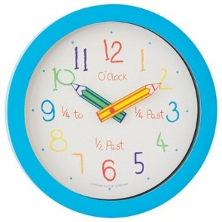
School Day | 9.00-3.00pm
Morning Break | 10.40-11.00am
Lunch | 12/12.30-1.15pm
Nursery | 9.00-3.00pm

General School Information
5. Parent Council
The role of the Parent Council is to:
- support the school in its work with pupils
- represent the views of all parents
- encourage links between the school, parents, pupils, pre-school groups and the wider community
- report back to all the parents in the school (called the Parent Forum)
- play a role in the appointment of Head Teachers and Depute Head Teachers
- support the school and pupils during school inspections.

Further information on the role of Parent Councils can be found in the guidance on the Parental Involvement Act.
www.scotland.gov.uk/Publications/2006/09/08094112/5
Our Parent Council Chairperson is Rhanna Whiteford; you can contact them using the following e-mail address: miltonprimarypc@gmail.com
Staff and pupils very much appreciate the help given by the Parent Council to the school. New members are welcome at all times.
6. Parental Involvement
The current pandemic has affected the way in which we are able to engage with parents, and this may change further depending on how the pandemic progresses. For the latest information, please contact the school.
At Milton Primary we believe that through building a positive partnership with you we can enable your child to be the best that they can be. The success and strength of the school lies in the positive relationships between staff, pupils and their parents.

Good communication with the school will always lead to a better outcome for your child. We always welcome parental interest in the welfare of our pupils.
We work very hard to keep you informed regarding your child’s progress and any key decisions being made about their education.
Parental information is obtained from questionnaires issued regularly at Parent evenings and from Parent Forums. The Head Teacher may ask you some questions in the playground from time to time just to ensure that we are always up to date with your thoughts on the progress of the school.
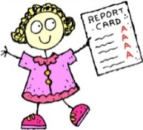
A “termly planner” is issued by class teachers at the beginning of each term to keep you abreast of their plans for the term. This details each of the curricular areas.
Parents are kept informed of their children’s progress through twice yearly parent
appointments and an annual written report in June.

Parents will be informed immediately if the teacher feels at any time that there is cause for concern over a child’s work or behaviour.

The school makes very good use of an online profile as a way of sharing the work of pupils with parents while maintaining a log of pupils’ learning journey. This programme is called Seesaw which is a student-driven digital portfolio that empowers students of all ages to independently document and share what they are learning at school. Through Seesaw you will be able to see some of the work that your child is undertaking in class. You will be issued further information about this from your child’s Class Teacher.

You can also keep up to date with what is going on in School via our main School Blog- www.miltonprimary.com
7. Pupil’s Absence
Good attendance is vital if pupils are to achieve their full potential. But if a pupil is absent from school, a parent or guardian must phone the school on the first day of absence, on the school number 01862 842 537. When returning to school after an absence, the parent or guardian must give written reason for the time absent.
Permission to leave during the school day: If a pupil needs to leave during the school day for an appointment etc, pupils need to bring with them a note from parent or guardian. Pupils must report to the school reception, be collected by an adult and ‘sign out’. If returning the same day, they must report again to the reception and ‘sign in’. Where possible, medical and dental appointments should be made outwith school hours.
If pupils fall ill during the day, parents are contacted for them to collect their child, therefore it is essential that we have up-to-date day time contact numbers and emergency contact numbers for all pupils.
Schools are required to keep an attendance register by law. We have a responsibility for the care and welfare of all pupils during the school day, therefore need to know the whereabouts of absent pupils.
When parents are considering whether or not to remove their children from school for a family holiday, they should be aware that such a decision:
- will result in a significant loss in classroom experience;
- will result in a pressure to ‘catch up’ on missed work by pupils;
- could result in pupils missing assessments with consequential impact on pupils and teachers;
- could result in the loss of curricular activities;
- will affect school attendance records and efforts to raise standards of attendance;
- under the guidance issued at a national level, most family holidays will be coded as unauthorised absence, only in exceptional cases will the absence be recorded as authorised.
In conclusion, we would ask parents to be aware of these considerations when making decisions on planning holidays during term time. We have enclosed a link to the school term dates on the Highland Council website to aid parents in planning any holidays they may be considering
https://www.highland.gov.uk/info/878/schools/32/school_term_dates
If parents decide to make holiday arrangements during school term, this should be confirmed in writing to the Head Teacher.
During the current pandemic we may need to amend our approaches to recording attendance, for example if it becomes necessary for pupils to work from home. For more details please contact the school.
8. Complaints Procedure
If a parent has any concerns they should contact the Head Teacher in the first instance.
The school will always endeavour to resolve issues by listening to parents and seeking solutions in partnership. Should a situation not be resolved, parents can contact the Area Manager Mr Derek Martin on 01349 868603.

9. Transport
Please note that transport is not a school responsibility and any queries should be addressed to the Transport Development Officer, Highland Council, Glenurquhart Road, Inverness, IV3 5NX, or public.transport@highland.gov.uk.
www.highland.gov.uk/info/878/schools/12/school_transport
Transport arrangements are those laid down by the Secretary of State for Scotland.

Children will receive free transport under the age of eight years if two or more miles from school, and if over eight years, if three or more miles from school.
The areas covered by taxi are Arabella, Meddat Bridge, Kildary, Delny, Tarbat, Tullich and Barbaraville.

10. Placement Requests
Each school serves its own particular catchment area.
Milton Primary Catchment area can be viewed online: www.highland.gov.uk/downloads/file/6988/milton_primary_schoolpdf
Pupils whose homes are located in that area will have priority in being allocated a place in the school. However, parents have the right to specify the school in which they wish to place their child, through making a placement request. Application must be made to the Area Education Manager, request forms can be obtained from: www.highland.gov.uk/info/878/schools/11/school_enrolment/2
Transportation to and from school, for placing request pupils, is a parental responsibility.
11. School Ethos & The Curriculum at Milton

The curriculum is the totality of experiences which are planned for children and young people throughout their education at Milton Primary.

The curricular guidelines offer a range of experiences and outcomes which children should meet at various stages in the primary school.

There are five levels (Early, First, Second, Third and Fourth) which are a progression in attainment and experience within each curricular area.
The experiences and outcomes within the Early Level should be attainable in the course of Nursery and Primary 1 by almost all pupils.
The experiences and outcomes within the First Level should be attainable in the course of Primary 2, 3 and 4 by almost all pupils.
The experiences and outcomes within the Second Level should be attainable in the course of Primary 5, 6 and 7 by most pupils.
The experiences and outcomes within the Third and Fourth Levels should be attainable in the course of Secondary years 1, 2 and 3 by most pupils.

At Milton Primary School we provide a curriculum which fully embraces the four contexts for learning of Curriculum for Excellence.

Literacy, Numeracy and Health and well-being are at the heart of our Curriculum. We plan, when appropriate, in an interdisciplinary way - this allows the children to make connections across learning/subject/idea and apply their skills in new ways.

Some sensitive issues are covered as part of our Health and Wellbeing Programme such as Sex and Relationships Education. Anyone wishing to see Sex and Relationships Education materials may do so by appointment or they may contact the Head Teacher if they have any questions.

Parents have the right to withdraw their pupils from Sex and Relationships Education. Any parent or guardian wishing to do so must inform the school in writing.

Special arrangements will be made for pupils whose parents do not wish them to participate in religious observance.

Curriculum Areas & Subjects
- Languages
- Mathematics
- Health and Wellbeing
- Expressive Arts
- Science
- Social Studies
- Religious and Moral Education
- Technologies

The curricular areas are not structures for timetabling at Milton. Staff have the freedom to think imaginatively about how to organise and plan learning.
Specialist teachers visit the school at times; they inspire, stretch and motivate our pupils.

Ethos and life of Milton Primary as a community
A positive climate of respect and trust based on our Golden Rules is promoted by all:
- We are gentle
- We are kind and helpful
- We listen
- We are honest
- We work hard
- We look after property

All learners contribute to the life and work of the school. All learners are community members they play an active part in putting school community values into practice. Everyone participates responsibly in decision making.

Opportunities for Personal Achievement
- Learners have a sense of satisfaction every day.
- Achievement is acknowledged and underachievement is challenged.
- We build motivation, resilience and confidence.
- We have Milton Star Assemblies to celebrate the success of individuals.

Interdisciplinary Learning
- Children may participate in one-off projects or longer courses of study.
- Learning is purposeful.
- Ensures progression in skills, knowledge and understanding.
- Provides opportunities for mixed stage learning which is interest based and where learning goes beyond subject boundaries.
- We take every opportunity to work with partners.
- Skills for learning, life and work are developed.

12. Promoting Positive Behaviour

Milton Primary uses the Jenny Mosley model of Golden Rules, Golden Time and Circle Time as a whole-school approach to enhancing self-esteem and positive behaviour and relationships within the school. All of the children and adults are involved and we hope that you will become involved too by encouraging your child and possibly adopting the same approach at home. In any case, you won’t be able to avoid them in school – they are everywhere!

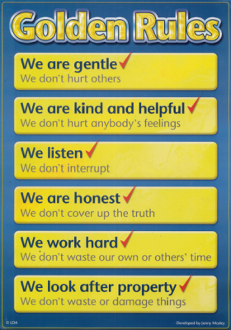

As a reward for on keeping the ‘Golden Rules’, children are awarded ‘Golden Time’ – 30 minutes on Friday afternoons to select an activity of their choice to play or do, eg a board game, using construction materials, painting or using computers.
Golden Time may be deducted if children have not kept the rules (time can be ‘won back’ if an improvement in their behavior is shown). If your child’s behaviour is giving cause for concern you will be asked to attend a meeting to discuss the best way forward.
For further information on any school policy please contact the Head Teacher or visit the link below for School policies, procedures and guidelines:
www.highland.gov.uk/info/893/schools_-_general_information/29/school_policies_procedures_and_guideline

The guidance link below provides an overview of the current policy and legislative environment providing the rationale for the development of positive relationships in schools, early years’ establishments and wider children’s services. It outlines the framework within which we operate in Highland and explains many aspects of child development that are critical to the understanding of the development of positive relationships.

file://highlandcouncil.gov.uk/StaffPersonal/sutherlandi/Downloads/PPR_Framework_and_Guidance.pdf

- If you as a parent are finding things challenging at home please refer to the following website for support…: https://www.children1st.org.uk/help-for-families/parentline-scotland/

13. Assessment & Reporting

Teachers use a range of ways of assessing the children. Assessments are ongoing and formative, this means that children are kept well informed about their own next steps in learning. Assessments may include observation, questioning and tests to see how a child is progressing and what their next steps in learning should be. We will share this with parents in reports, at parents’ evenings and other meetings as requested by parents.
Profiling
Throughout the school, Nursery – P7, children are learning to make connections across the curriculum, to take pride in their work, to know what they are learning and to be able to explain why they are learning certain things. All children have a Personal Learning Profile (in Nursery this is known as their Learning Journey) in which their work, their targets, their reflections, teacher comments and feedback are stored. The Profiles are available for parents to look at throughout the year and we encourage you to take time to write in these records highlighting your thoughts about your child’s progress.
Reporting

Parents will be invited into school twice each year for a formal Parent Contact meeting; the purpose of this meeting is to discuss the child’s progress and next steps.
At the end of the school year a written report is issued to parents in June which summarises the child’s progress in relation to what is appropriate for their age and stage.
14. Enrolment
Enrolment of new entrants to P1 takes place during the week beginning Monday 25th January 2021 and Nursery enrolment will take place week beginning Monday 8th February 2021. Dates for this are advertised in the local press.

Parents offered or seeking a place for their child at Milton Primary School are welcome to visit the school prior to enrolment by arrangement with the Head Teacher.
If you are unable to use the enrolment week please contact the school to arrange a mutually convenient time.

There are 3 intakes per session for Nursery, these take place in August, January and April, information on which intake your child is eligible for can be found on the Highland Council website or at the school office.
15. Transition

Pupils transfer to Invergordon Academy or Tain Royal Academy.
Government Legislation gives parents the right to send children to the school of their choice.
Liaison exists between the schools involving staff meetings and exchange visits of teachers to ensure that the transfer from Primary to Secondary is made as smooth as possible.
P7 pupils are visited by guidance and subject teachers, and in the summer term are taken to visit the Academy of their choice.
Parents of P7 pupils will receive literature from the Head Teacher of the Academy and an invitation to visit in the Summer term.

Further information may be obtained from the Rectors:
Tain Royal Academy Invergordon Academy
Mr M. Jones Mr M. Aitchison
Scotsburn Road Academy Road
Tain Invergordon
01862 892121 01349 852362

At Milton a structured and positive planned transition from different stages ensures that our children move through the education system with ease.

Pre-School to Primary School: Opportunities for children attending nursery to be included in school events include:
- Continuous interaction with Primary 1 pupils as part of our Early Years Class.
- Morning break in the Summer term with a play-piece in the playground instead of a snack.
- Taking part in whole school theme days and special events.

Aims for induction into Primary:
- To make a happy transition from home to school
- To encourage all parents to be partners in their child’s education
- To assist parents in helping their child towards readiness for school
- To support the pre-school child towards independence
- To ensure that any relevant information from outside agencies is acknowledged and acted on particularly in regard to children with special needs

16. Support for Pupils
Many children may need support to help them with learning while they are at school. For some children the support they need might be for a short time, for example following a bereavement when they may be upset and unable to concentrate and may be supported by having someone to talk to at school. Or, they made need longer term or more complex support from several people or organisations. The support provided to children and young people will be tailored to their individual needs.
The Additional Support for Learning Act sets out a framework for the provision of support for learning. This includes the identification of learning needs, and the planning and monitoring of support provided. If you are concerned that your son or daughter may need some support to help their learning you should discuss this with their school in the first instance. Our Support for Learning Teacher is Mrs Sellar she is based at Milton Primary on a Thursday and a Friday. For further information on Additional Support Needs please visit:
www.educationscotland.gov.uk/Parentzone/additionalneeds/learningact/introduction.asp
Children with Additional Support Needs need support to help them learn. Some children require more help than others. We follow The Highland Practice Model staged approach to assessing, identifying and supporting pupils. In this model every child has a ‘named person’ who is responsible for making sure that the child or young person has the right help to support his/her development and well-being. If you have a concern about your child please contact your child’s class teacher in the first instance or the ‘named person’, the Head Teacher. Sometimes a Child’s Plan may be put in place to help organise, monitor and regularly review your child’s progress. If you wish to find out more about The Highland Practice Model or the Child’s Plan you can access more information at:www.highland.gov.uk/learninghere/supportforlearners/generalguidance/planning/
There are also Information sheets available at: www.chipplus.org.uk click on Education.
A Support and Inclusion Worker may be asked to contribute to supporting your child. The SIW works in collaboration with the support team in school. Further to this the SIW works to support families in their own communities and works with individual pupils and small groups - offering a further level of support as required.
17. School Improvement
www.educationscotland.gov.uk/scottishschoolsonline/schools/miltonprimaryschoolhighland.asp

Please click on the above link to view our latest report Inspection Report from Education Scotland.
School Policies and Practical Information

18. Term Dates & School Hours
2020-2021

Autumn
- Autumn term starts – 11th August 2019

Autumn
- Autumn term starts – 11th August 2020
- Autumn term ends – 9th October 2020

Winter
- Winter term starts – 26th October 2020
- Winter term ends – 22nd December 2020

Spring
- Spring term starts – 6th January 2021
- Mid-term break – 15th and 16th February 2021
- Spring term ends – 1st April 2021

Summer
- Summer term begins – 19th April 2021
- Summer term ends – 25th June 2021

Public holidays
- Good Friday – 2nd April 2021
- Easter Monday – 5th April 2021
- May Day – 3rd May 2021

In-service days
- 16th August 2020
- 13th September 2020
- 14th September 2020
- 17th February 2021
- 6th May 2021

2021-2022

Autumn
- Autumn term ends – 8th October 2021
Winter
- Winter term starts – 25th October 2021
- Winter term ends – 22nd December 2021

Spring
- Spring term starts – 6th January 2022
- Mid-term break 21st and 22nd February 2022
- Spring term ends – 1st April 2022

Summer
- Summer term begins – 19th April 2022
- Summer term ends – 30th June 2022
19. Homework
In all classes, the work done at home should be within the capabilities of the child and will be covering a variety of the Experiences and Outcomes in different
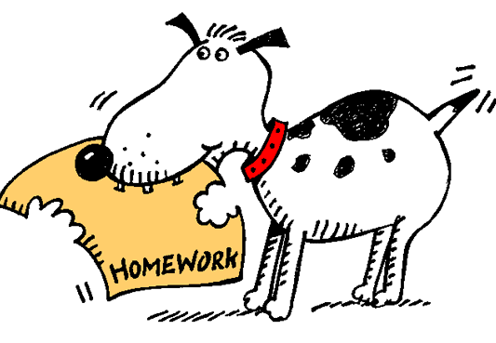
curricular areas. The right sort of encouragement and help at home is invaluable. If at any time you are unsure about what is expected from a homework task, please just contact the school.

We do not want Homework to ever become a stressful event or cause friction in a household. Likewise if your child refuses to do their homework, despite your best efforts, please bring this up with the class teacher.

20. School Uniform
We ask that all pupils wear school uniform. We believe it promotes equality, gives a sense of identity and pride in our school and that it is smart and economical. The range of school wear –red sweatshirts, navy or red polo shirts all with the school design embroidered on them are available through the school or by visiting:
www.schoolwearmadeeasy.com or Macgregor Industrial Supplies

All children should bring a PE kit to school with them on specified gym days. They should bring tools for learning such as; a pencil, rubber, ruler etc. All children are required to have indoor shoes as they are asked to change shoes when they come into school each morning. We love to learn outside and in all weathers so the children need to have a waterproof/warm jacket for adverse weather.

21. Lost Property
Children are permitted to bring a toy to school on a Friday for their Golden Time. If they do so it is entirely their own responsibility and risk. All money relating to school i.e. dinner, trips, photographs etc. should be sent to school in a sealed and labelled envelope and given to the class teacher first thing in the morning. All clothes and other belongings should be clearly marked with the child’s name. Parents are asked to make regular checks, each day if possible, to make sure nothing has gone astray.

22. Lunchtime Choices
All Primary 1 to 3 pupils are entitled to a free School Meal. This Scottish Government funded initiative entitles all Primary 1 to 3 children to a free school meal at lunch time only – you will still need to provide your child with money for any other service provision in school such as breakfast club or snack bar. The meal is completely optional and all the choices provided are healthy and nutritious and meet all the requirements of the Scottish School’s Health Promotion and Nutrition Act.
School Meals cost £2.30 for Primary 4 to 7 pupils and just keep getting better, with better quality food, healthier meals, larger portion sizes and more and better choices. If a pupil has special dietary needs, please inform the school. Free meals can be claimed in certain circumstances, for information and application form please see:
www.highland.gov.uk/info/899/schools_-_grants_and_benefits/10/free_school_meals_and_assistance_with_clothing
Application forms are available from the school reception.

24. Health Promoting School
As a Health Promoting school we also encourage pupils, staff and parents to think about healthier lifestyles. Healthy living is a regular topic in classes. We have a School Travel Plan which promotes safe and healthy routes to school. Staff take part in health promotion activities. We value all the activities that make up a healthy and happy community. Every Friday is Fruity Friday; we would encourage all children to bring a piece of fruit for snack to earn some extra house points.

25. Extra-Curricular Activities
Throughout the year pupils may participate, within and out with normal school hours, in activities such as, badminton, homework-club, cross country, computing, art etc. We like to encourage parents to be involved with extra-curricular activities. If you would like to take a group or assist with an extra-curricular activity or club please do contact the head teacher.

26. Administration of Medicines
National Guidance on the Administration of Medicines in Schools has been issued by the Scottish Government. https://www.gov.scot/publications/supporting-children-young-people-healthcare-needs-schools/

NHS Highland, Highland Council and school staff will work collaboratively to ensure that pupils receive the service they need in the way most appropriate to their personal circumstances. We will work with pupils and parents/carers to support the healthcare in our school, making reasonable adjustments that children and young people with healthcare needs might need and require.

Where appropriate, we will make arrangements for staff providing healthcare to pupils to receive appropriate training from a health professional, or other accredited source in the care they are providing.
Assistance with intimate care may be needed by children in any school and this will be provided if required to support these needs quickly and with respect for children's privacy, dignity and rights.
If your child requires medication, please note that this will only be administered by staff when there is clear written guidance from a parent/carer, providing:
- The name of the medicine, the quantity of the medicine to be given, the time it has to be given.
- As far as possible prescriptive medication should be given at home by parents/carers. If it is required to be given in school, the medication should be unopen, clearly marked with the directions from the pharmacist and administered as part of an agreed medical protocol.

Please do not send medicines to school with your child without having previously completed the appropriate forms.

27. Minor injuries
School will only deal with minor cuts and bruises, these will be cleaned and a plaster applied. You will be notified if your child receives any form of First Aid.

28. Adverse Weather / Closure
Schools now have a dial-in service if there is risk of closure due to adverse weather. This allows parents to listen to a recorded message from the
Head Teacher. It is an enhancement to the present service and does not replace existing methods of giving out information, such as radio broadcasts, described in the schools Adverse Weather Guidelines which are issues to parents every year.
To use the service dial 0800 564 2272 and enter Milton’s pin number when prompted: 04 2630.
You can also access the highland school closure website on: www.highland.gov.uk/info/827/education_and_learning for school closure information.
Regarding children living in Milton Village it is our policy to keep the school open provided the heating, lighting, fabric of the school are in working order.
In an emergency situation e.g. the failure of the electricity supply, heating problems, the onset of very severe weather, we must warn parents that it may be necessary to close the school without prior warning. If this does happen we will make contact with every home and ensure that every child is matched up with a parent/carer.
Pupils who walk to school will be expected to return to agreed home on foot. All infants (P1-3) will be escorted home by an older child/brother/sister.
The parents of pupils who use school transport will be contacted to inform them that the children will be returning home early and arrangements will be made to ensure these children return home to parents/carers.
It is essential that the school has a complete and updated record of the address and phone number of the home and emergency contact.
As a parent if you are in any doubt as to the danger from severe weather please keep your children at home.
If you have sent your children to school and the weather worsens you are most welcome to come to the school, and ask to take your child home.
In the event of a major evacuation our school assembly point is the Milton Bowling Club.

29. Fire Precaution
Fire drills are held once a term. Displayed outside the staffroom door, in the middle area of the school, in the nursery and in the school office is our plan for dealing with a major incident on the premises.

30. Access to Pupil Records
The school pupil records (Scotland) Regulations 1990 extend to parents the right of access (with certain specific exceptions) to any record held by the Authority in relation to their child. Parents may make application to the Head Teacher.

31. Data Protection Act 1998
Information on pupils, parent and guardians is stored on a computer system and may be used for teaching, registration, assessment and other administrative duties. The information is protected by the data Protection Act 1998 and may only be disclosed in accordance with the codes of practice. Further information can be obtained from www.scotxed.net.

32. Transferring Educational data about pupils
The Scottish Government and its partners collect and use information about pupils through the Pupil Census to help to improve education across Scotland. This note explains why we need this information, how we use it and what we do to protect the information supplied to us.
Why do we need your data?

In order to make the best decisions about how to improve our education service, Scottish Government, education authorities and other partners such as the SQA and Skills Development Scotland need accurate, up-to-date data about our pupils. We are keen to help all our pupils do well in all aspects of school life and achieve better examination results. Accurate and up-to-date data allows us to:
- plan and deliver better policies for the benefit of all pupils
- plan and deliver better policies for the benefit of specific groups of pupils
- better understand some of the factors which influence pupil attainment and achievement
- share good practice
- target resources better
- enhance the quality of research to improve the lives of young people in Scotland

33. Data policy
Information about pupils’ education is collected through our statistical surveys in partnership between the Scottish Government and Local Authorities through the ScotXed Programme which aims to help schools and Local Authorities by supporting efficient collection, processing and dissemination of statistical information. The Scottish Government then provides analysis of the data to support research, planning, management and monitoring of education services as well as to produce National Statistics publications.
Education data within Scottish Government is managed effectively by secure systems and is exploited as a valuable corporate resource, subject to confidentiality restraints. As part of its data policy, Scottish Government will not publish or make publicly available any information that allows individual pupils to be identified, nor will data be used by Scottish Government to take any actions in respect of individuals. Data is held securely and no information on individual pupils can or would be made publicly available by Scottish Government.
The individual data collected by Scottish Government through the Pupil Census is used for statistical and research purposes only.

Your data protection rights:
The collection, transfer, processing and sharing of ScotXed data is done in accordance with the Data Protection Act (1998). We also comply with the National Statistics Code of Practice requirements and other legislation related to safeguarding the confidentiality of data. The Data Protection Act gives you the right to know how we will use your data. This note can give only a brief description of how we use data. Fuller details of each individual ScotXed survey, including the purpose of each and the published data, can be found on the ScotXed website (www.scotxed.net).
Scottish Government works with a range of partners including Education Scotland, Skills Development Scotland and the SQA. On occasion, in order to help meet our aim of improving the life of young people in Scotland, we may make individual data available to partners such as the National Registers of Scotland to carry out research relating to the national population census and also academic institutions and organisations to carry out additional research and statistical analysis to meet their own official responsibilities. Any sharing of data will be done under the strict control of Scottish Government, and will be consistent with our data policy. This will ensure that no individual level data will be made public as a result of the data sharing and that these data will not be used to take any actions in respect of an individual. Decisions on the sharing of data will be taken in consultation with relevant colleagues and individuals within and outwith Scottish Government. At all times pupils’ rights under the Data Protection Act and other relevant legislation will be ensured.
Concerns
If you have any concerns about the ScotXed data collections you can email the Head of Schools Analysis at ScotXed@scotland.gsi.gov.uk or write to The ScotXed Support Office, Area 2D, Victoria Quay, Leith, EH6 6QQ. Alternative versions of this page are available, on request from the ScotXed Support Office, in other languages, audio tape, Braille and large print.

34. Equality and Inclusion
For up-to-date information please see:
www.highland.gov.uk/info/751/equality_diversity_and_citizenship/313/equal_opportunities
In summary, our activities in school should ensure that we:
Eliminate unlawful discrimination, advance equality of opportunity and promote good relations. Activities should not discriminate against any of the following ‘protected characteristics’ age, disability, race, religion or belief, sex, sexual orientation, gender reassignment, pregnancy and maternity.

35. Protection of Children
From time to time incidents can occur within the school setting which cause concern and could indicate that a pupil is suffering some form of abuse.
In terms of Highland Child Protection Committee Inter-agency Protection Guidelines, Education Service staff must report such incidents to Social Work Services which can lead to a joint Social Work/Police investigation.
All agencies involved in Child Protection are obliged to make the welfare of children their paramount consideration and this will be the priority for Education Service staff.
COPIES OF CHILD PROTECTION POLICY GUIDELINES are available from Milton Primary School or online at:
www.highland.gov.uk/info/1361/childcare_and_family_care/438/child_protection

Whilst the information in this handbook is considered to be true and correct at the date of publication, changes in circumstances after the time of publication may impact on the accuracy of the information.

Please recycle this Handbook


Or return to Milton Primary School

