How to access Google Meet

You will find the Google Meet App in amongst the other apps in the Google Suite. Or you will need to download it onto your device (including a smart phone). Click the 9 dots at the top right hand of the screen and choose ‘Meet’. See image below.

All you need to access this is your child’s school email address and password. The address will be your child’s first and second name with a . in the middle @invergordonacademy.org.uk. For example john.smith@invergordonacademy.org.uk If your child has never used the address before, the password is Password. If they have, then they will know their own password. Your child’s group leader will phone you this week to help you with this.

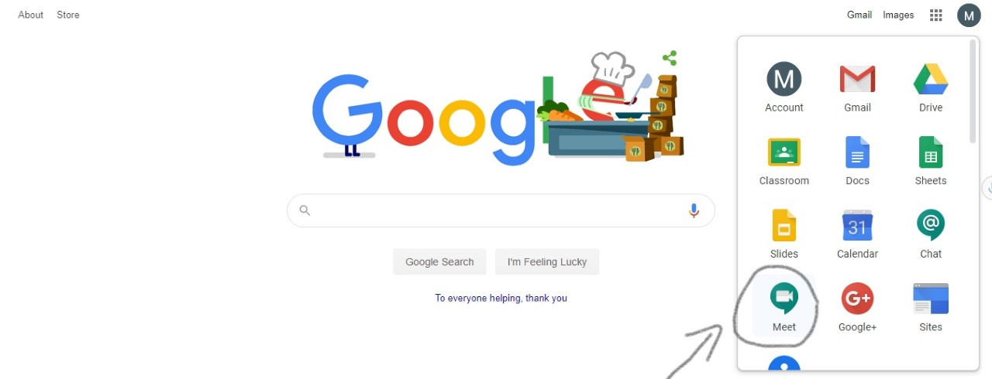

Once you have opened Google Meet, there should be an obvious link, with the group name that you will be given, to the Meet for your child's Key Worker. You just click on that link and join in. The link will only become available at the time and date that it has been set.

If you have any questions or if I can provide any support, please let myself or your child’s teacher know. My address is Suzanne.callander@highland.gov.uk

At the time of the meeting, it is helpful if your child mutes the sound if they are not speaking. This helps to reduce background noise.

Best wishes,

Suzanne Callander

Good evening,

I hope that you’ve all been enjoying some time out in the sunshine.

I would like to thank everyone for engaging with either the blog or Google classrooms over the past week. It’s been lovely to see all of the work and fun going on.

In line with new Highland Council policy, myself or Mrs Christie will continue to phone families who are not engaging every three days to see how we can support you. New guidance has been issued that we must follow. I will post details of this soon.

We have now set up Google Meet groups for all pupils at Milton P.S. Your child has been allocated a group with a staff member and other pupils in their class. The staff member in charge of your group will phone you with the details before the end of the week. They will tell you the unique group code, time and date of the meet. P4-7 already have access to Google regularly but this may be new for parents from nursery – P3. I have attached a ‘How to’ guide for you to follow.

The expectation is that your child is able to join their group each week at the same time for a short, informal chat with their friends and to see a friendly adult’s face from school. All of us are very excited to be able to see you as we’ve missed you all.

Thank you for your support,

Suzanne Callander

